IFIC
CIHI FHIR OAuth2 Credential Provisioning – Process Summary Version 1.0

Revision History
Rev | Date | Description of Change | By
1.0 | 2025-11-04 | Initial version of document | Darryl Poworoznyk

Table of Contents
Contents
Revision History 1
Table of Contents 2
Table Of Figures 3
Overview 4
Who should use this document 5
before you begin 6
creating and activating a cihi account 7
Step 1 – Access the CIHI Portal 7
Step 2 – Create a New User Profile 7
Step 3 – Activate Your Profile 7
requesting access to the irrs fhir submission service 8
Step 1 – Navigate to the Access Page 8
Step 2 – Select the User 9
Step 3 – Add / Revoke Services 10
Step 4 – Add a Comment 11
Step 5 – Submit 11
verifying system registration 12
Step 1 – Navigate to System Management 12
Step 2 – Verify Registered Systems 12
Retrieving your encryption key 14
Configuring ific for your facility 15
Support and escalation contacts 16

Table Of Figures

Figure 1 - My Services Dashboard 8
Figure 2 - Selecting Access for Yourself 9
Figure 3 - Confirm Selected Users and Add/Revoke Services 10
Figure 4 - System Registration and Options 12

Overview
This document provides detailed instructions for Long-Term-Care Facility (LTCF) organizations working with VitalHub’s Clarity system to register with the Canadian Institute for Health Information (CIHI) and obtain access credentials for FHIR data submissions through the IFIC (IRRS/FHIR Intermediary Component).
CIHI requires each submitting organization to create a CIHI account, register a system, and obtain endpoint credentials before data can be transmitted to the IRRS FHIR interface.
This guide explains how to:
- Register a CIHI profile
- Request access to the IRRS LTCF FHIR submission service
- Verify your organization’s system registration
- Retrieve encryption keys for secure submission

Who should use this document
This guide is intended for:
- Facility administrators and data coordinators responsible for CIHI submissions
- IT staff supporting Clarity
- Any organization required to onboard to CIHI’s IRRS LTCF program using VitalHub’s intermediary (IFIC)

before you begin
Please confirm the following before starting:
- You have an active business email address registered with your LTCF organization.
- Your organization is listed as a Submitting Organization under CIHI’s LTCF initiative.
- You have received an invitation or confirmation from VitalHub or CIHI to proceed with registration.
- You are aware of which environment you are setting up:
  - Vendor Test (pre-production / CIHI sandbox)
  - Facility Test or Production (live data submission)
If you are unsure, contact specializedcare@cihi.ca or support@vitalhub.com before proceeding.

creating and activating a cihi account

Step 1 – Access the CIHI Portal
Go to https://www.cihi.ca and click My Services in the top-right corner.

Step 2 – Create a New User Profile
If you do not have an account:
- Click Request Access: New / Revoke
- Select Create a new user
- Fill in your contact details and organization name
(use your facility’s registered name exactly as recognized by CIHI)

Step 3 – Activate Your Profile
You will receive an email from help@cihi.ca with the subject Activate your CIHI User Profile.
Click the activation link within two hours to finalize your registration.

requesting access to the irrs fhir submission service
Once logged into your profile, follow the access request process below. These steps are based on CIHI’s official Requesting Access to Products and Services User Guide (2024) but have been simplified for LTCF facility users.

Step 1 – Navigate to the Access Page
In the left navigation menu, select:
My Services → Request Access: New / Revoke
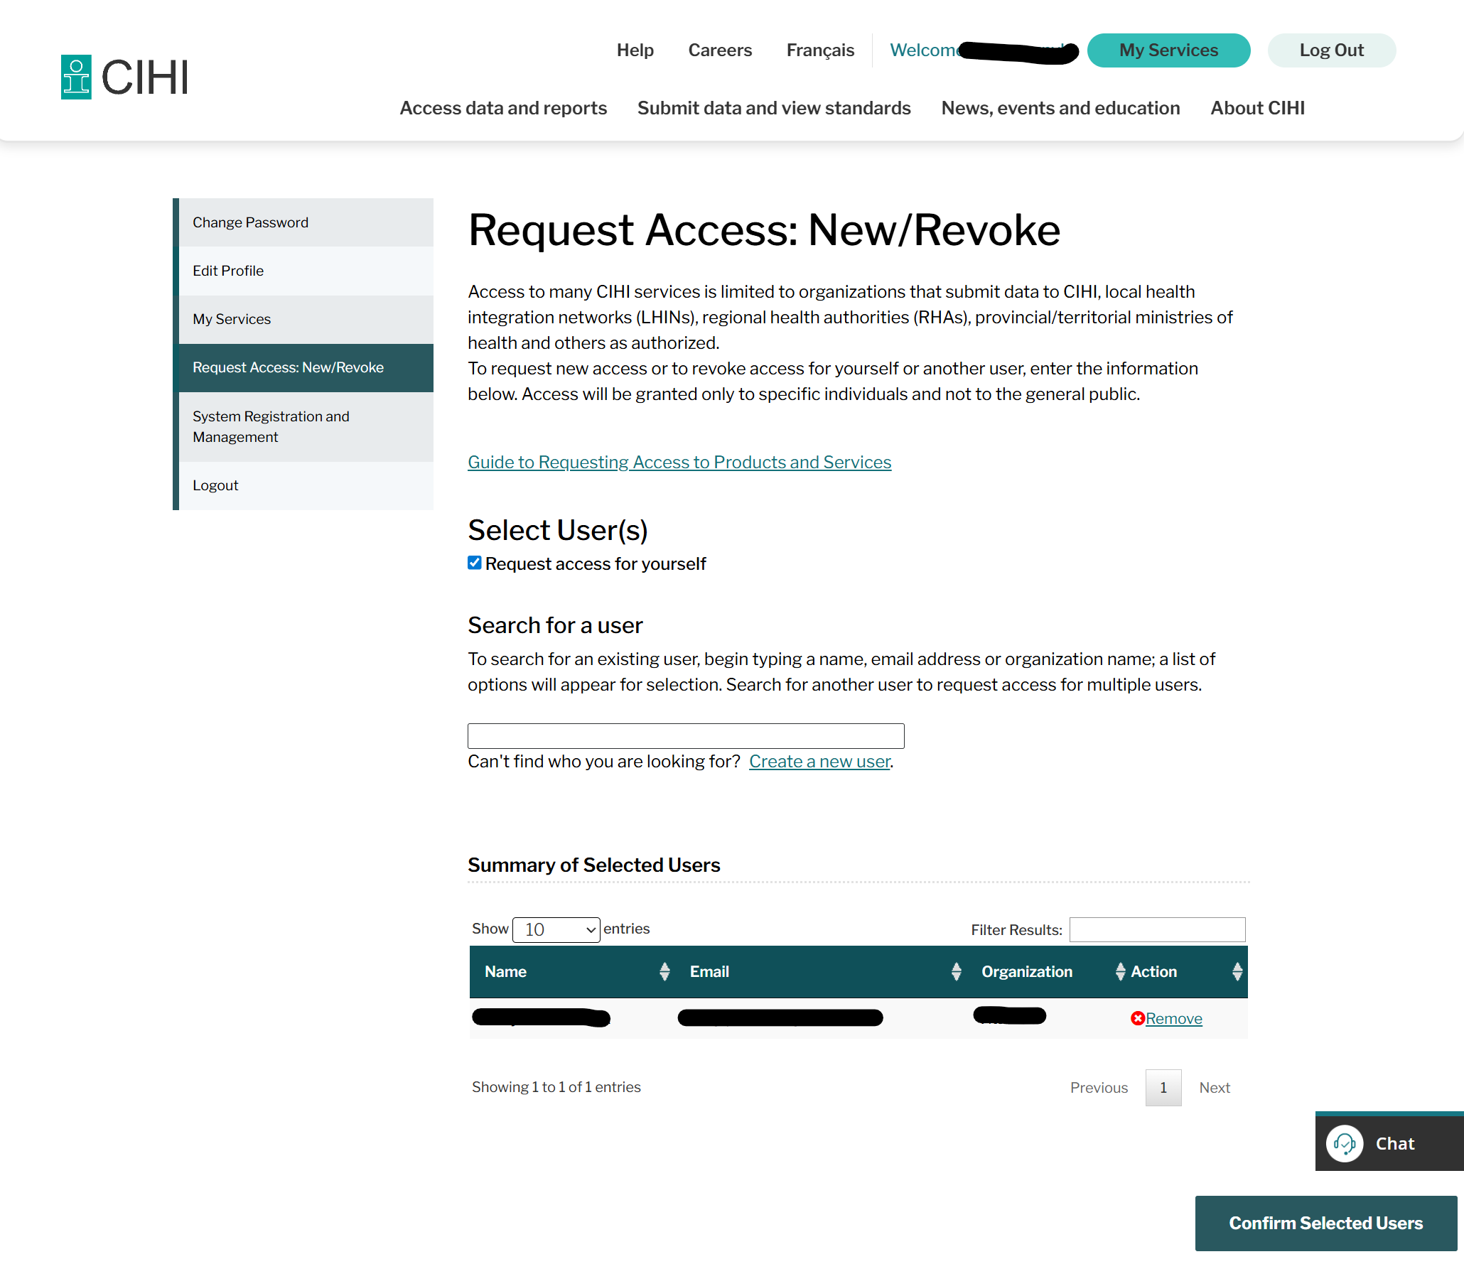
Figure 1 - My Services Dashboard

Step 2 – Select the User
- Tick Request access for yourself
- Ensure your Name, Email, and Organization appear in the Summary of Selected Users table
- Click Confirm Selected Users
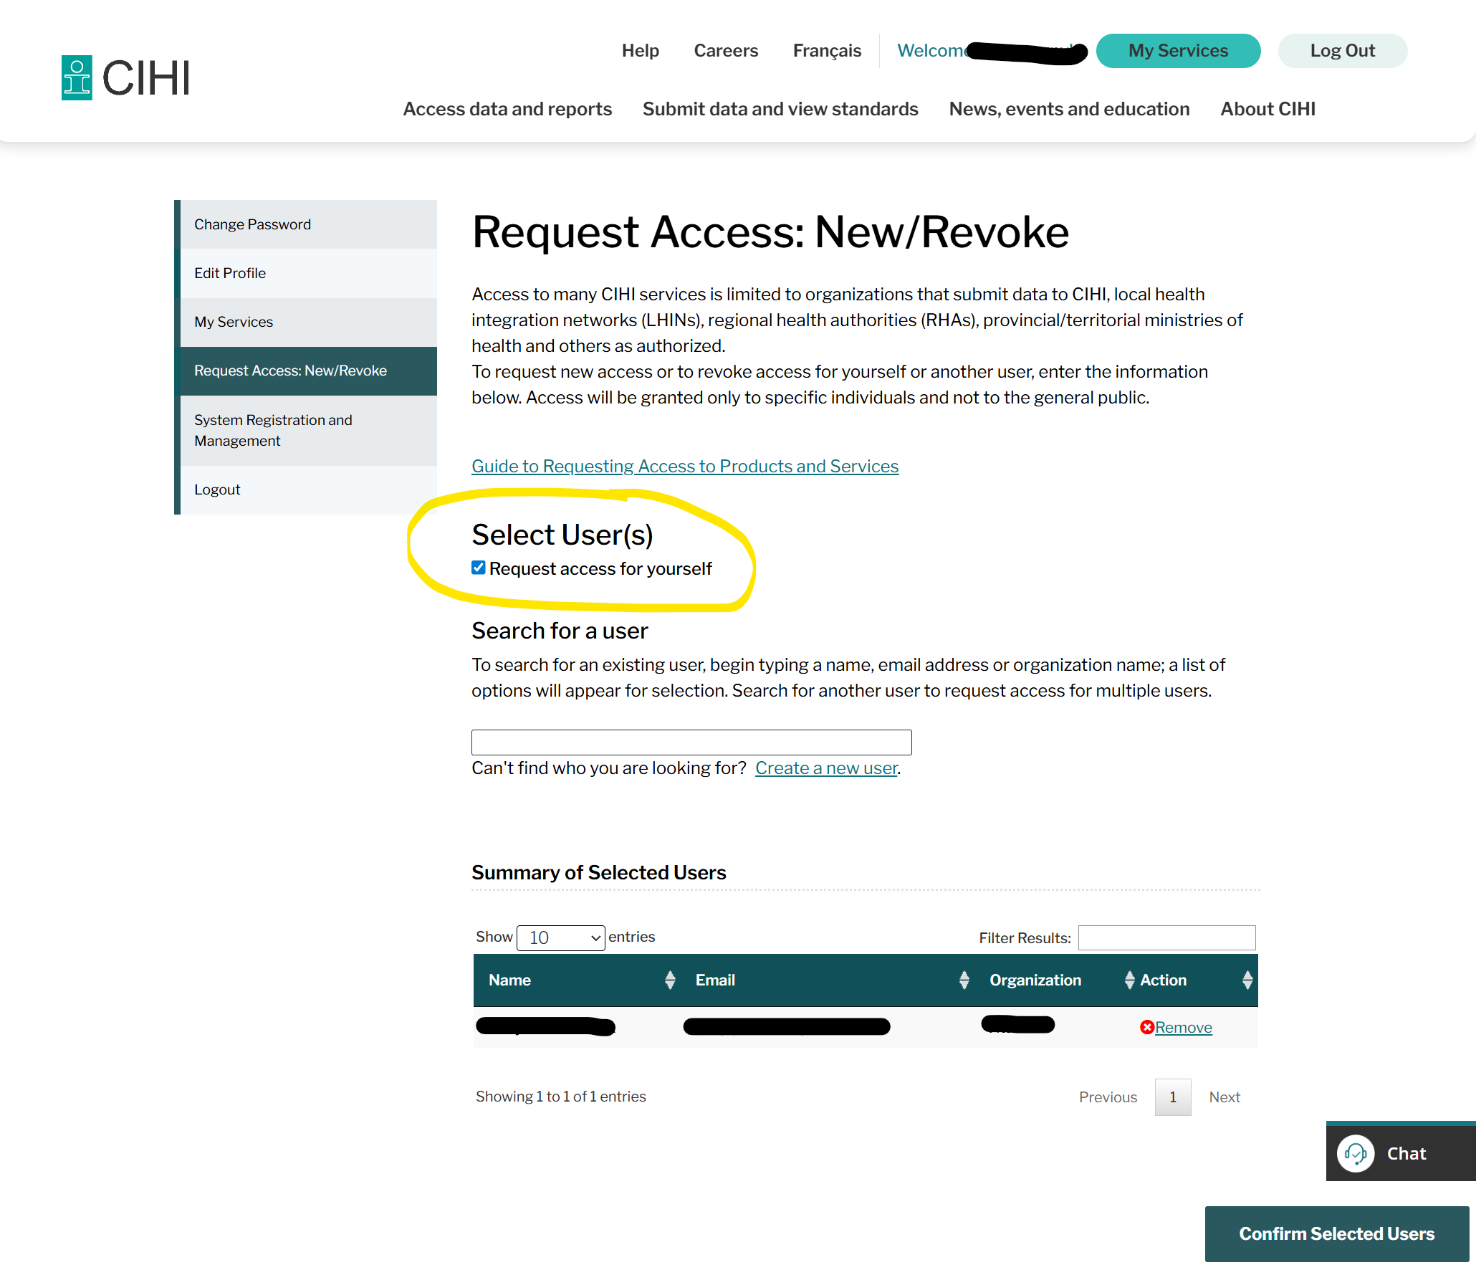
Figure 2 - Selecting Access for Yourself

Step 3 – Add / Revoke Services
- Click Add / Revoke Services
- In the search bar, type IRRS LTCF or FHIR
- When the IRRS Long-Term Care Facility FHIR Submission service appears, select Grant
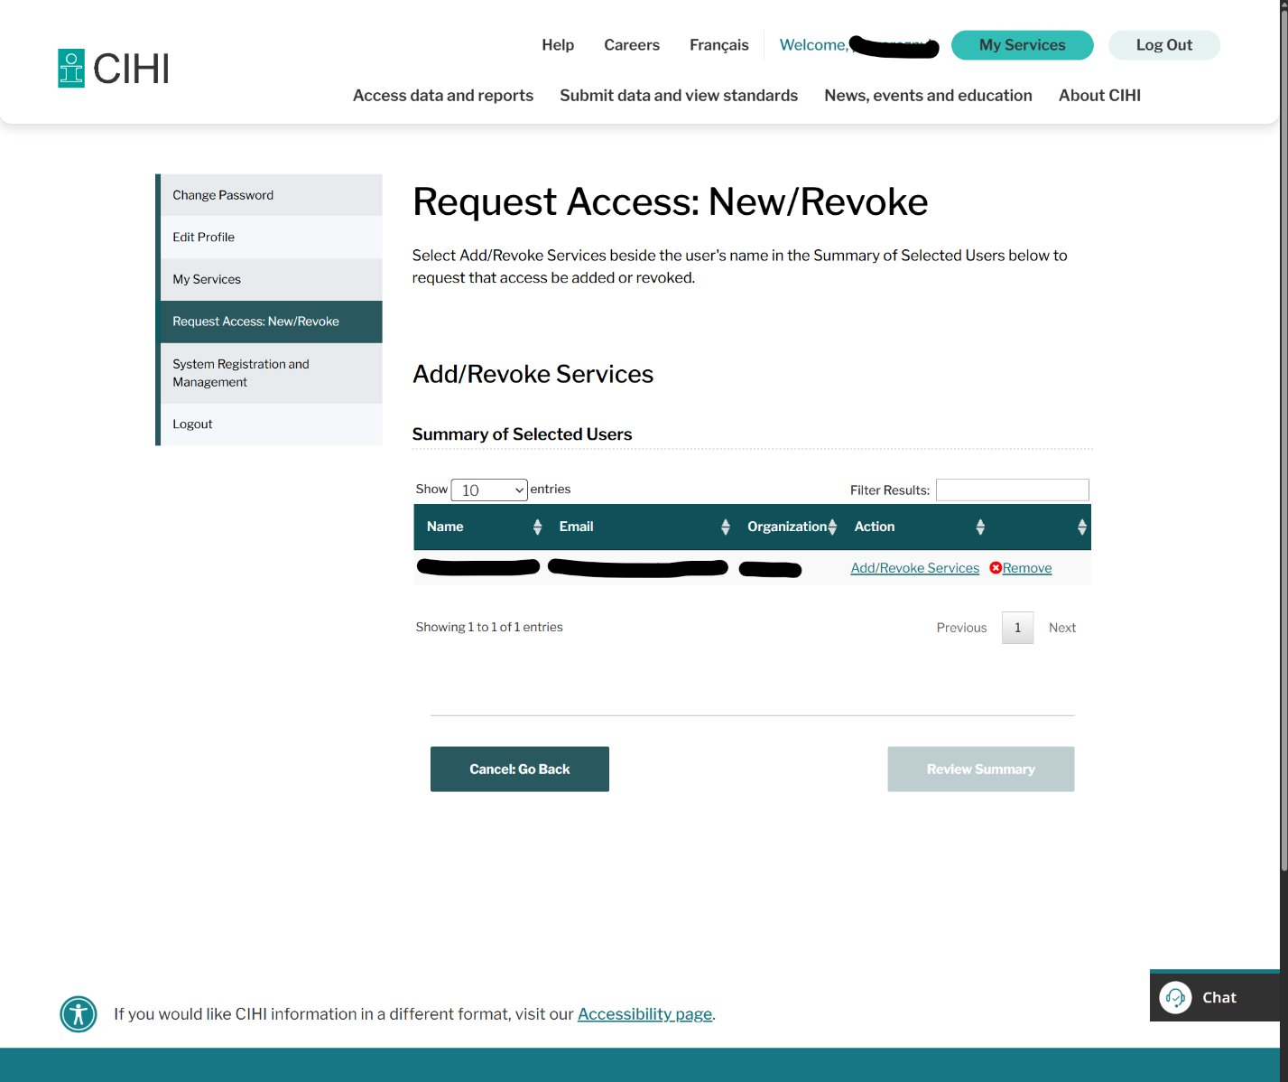
Figure 3 - Confirm Selected Users and Add/Revoke Services

Step 4 – Add a Comment
In the optional Comments field, enter:
Requesting access to IRRS LTCF FHIR Submission for facility onboarding via VitalHub IFIC intermediary.

Step 5 – Submit
Click Submit Request to send the request to CIHI for approval.
You will receive a confirmation email once it has been processed.
Typical approval time: 2–3 business days.

verifying system registration
Once your access has been approved, your facility will appear under System Registration and Management.

Step 1 – Navigate to System Management
- From the left panel, select:
My Services -> System Registration and Management

Step 2 – Verify Registered Systems
You should see one or more registered systems, for example:
System Identifier | Submission Purpose | Submitting Organization | Vendor | Software
ltcf-somecompany_cihi_productionkey1 | Production | IRRS organization for production | Your Facility | Our Software
ltcf-somecompany_cihi_productionkey2 | Production | IRRS organization for production | Your Facility | Our Software
(Do not click “Remove” or “New Key” unless directed by CIHI or VitalHub support.)

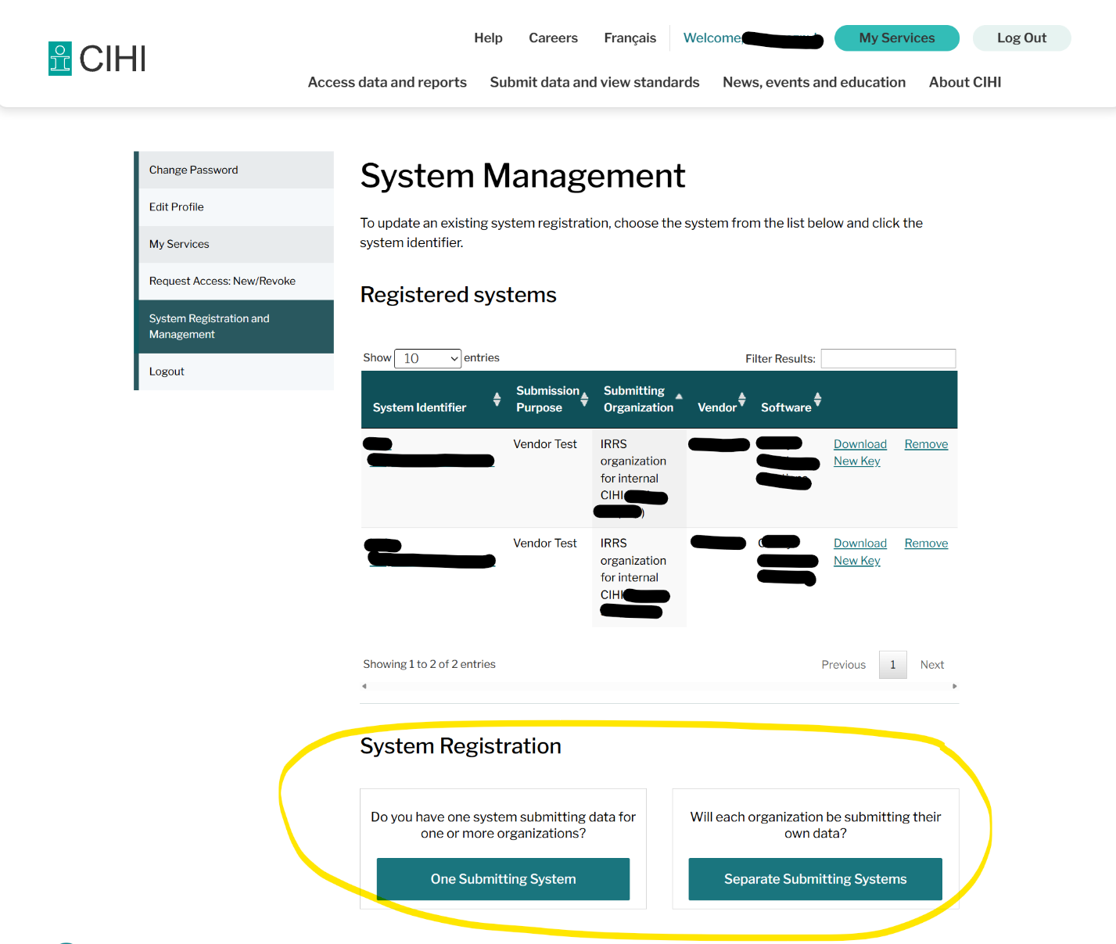
Figure 4 - System Registration and Options

Retrieving your encryption key
Each registered system is assigned a unique private key used by IFIC to authenticate submissions to CIHI’s FHIR API.
To download your key:
- Locate your registered system entry (e.g., ltcf-somecompany_cihi_productionkey1)
- Under Software, click Download next to Clarity Healthcare Solutions
- Save the .key file in a secure location (for example, your facility’s secure shared drive)
If you believe your key has been compromised, contact CIHI immediately and request a New Key.
This will revoke the old one and issue a new set of credentials.

Configuring ific for your facility
After your facility has obtained its private key and CIHI access credentials, refer to the “IFIC – Architecture and Execution Flow” document (Version 1.0) for full technical setup instructions and configuration details
IFIC - Architecture
That document—maintained by VitalHub—outlines:
- The configuration file structure (appsettings.json) and required parameters (database connection, authentication keys, and FHIR endpoint URLs).
- The directory and folder hierarchy used by IFIC (Queued, Processed, Errored, and RunLogs).
- Authentication flow, token exchange, and CIHI submission sequence.
- File lifecycle, logging, and error handling behavior.
If assistance is needed interpreting those settings or deploying IFIC in your local environment, please contact the VitalHub Integration Team (support@vitalhub.com) for step-by-step onboarding support.

Support and escalation contacts

Type of Issue | Contact | Email
Account creation or login | CIHI Help Desk | help@cihi.ca
IRRS or LTCF FHIR access | CIHI Specialized Care Team | specializedcare@cihi.ca
CIHI Learning Centre access | Education Services | education@cihi.ca
IFIC configuration or key assistance | VitalHub Integration Team | support@vitalhub.com

